Web programming

Week 9

23BCE5142

Harini S

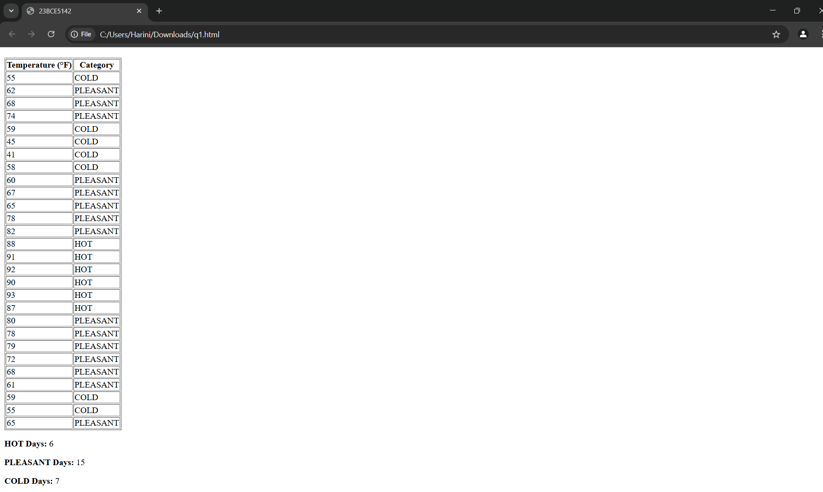<html lang="en">

<head>

    <title>23BCE5142</title>

</head>

<body>

    <h1>Temperature Classification in New York City</h1>

    <table border="1px">

        <tr>

            <th>Temperature (°F)</th>

            <th>Category</th>

        </tr>

        <tbody id="temperature-table">

        </tbody>

    </table>

    <div>

        <p><strong>HOT Days:</strong> <span id="hot-count">0</span></p>

        <p><strong>PLEASANT Days:</strong> <span id="pleasant-count">0</span></p>

        <p><strong>COLD Days:</strong> <span id="cold-count">0</span></p>

    </div>

    <script>

        const temperatures = [55, 62, 68, 74, 59, 45, 41, 58, 60, 67, 65, 78, 82, 88, 91, 92, 90, 93, 87, 80, 78, 79, 72, 68, 61, 59, 55, 65];

        let hotDays = 0;

        let pleasantDays = 0;

        let coldDays = 0;

        const tableBody = document.getElementById("temperature-table");

        temperatures.forEach(temp => {

            let category;

            if (temp >= 85) {

                category = "HOT";

                hotDays++;

            } else if (temp >= 60) {

                category = "PLEASANT";

                pleasantDays++;

            } else {

                category = "COLD";

                coldDays++;

            }

            const row = document.createElement("tr");

            const tempCell = document.createElement("td");

            tempCell.textContent = temp;

            const categoryCell = document.createElement("td");

            categoryCell.textContent = category;

            row.appendChild(tempCell);

            row.appendChild(categoryCell);

            tableBody.appendChild(row);

        });

        document.getElementById("hot-count").textContent = hotDays;

        document.getElementById("pleasant-count").textContent = pleasantDays;

        document.getElementById("cold-count").textContent = coldDays;

    </script>

</body>

</html>

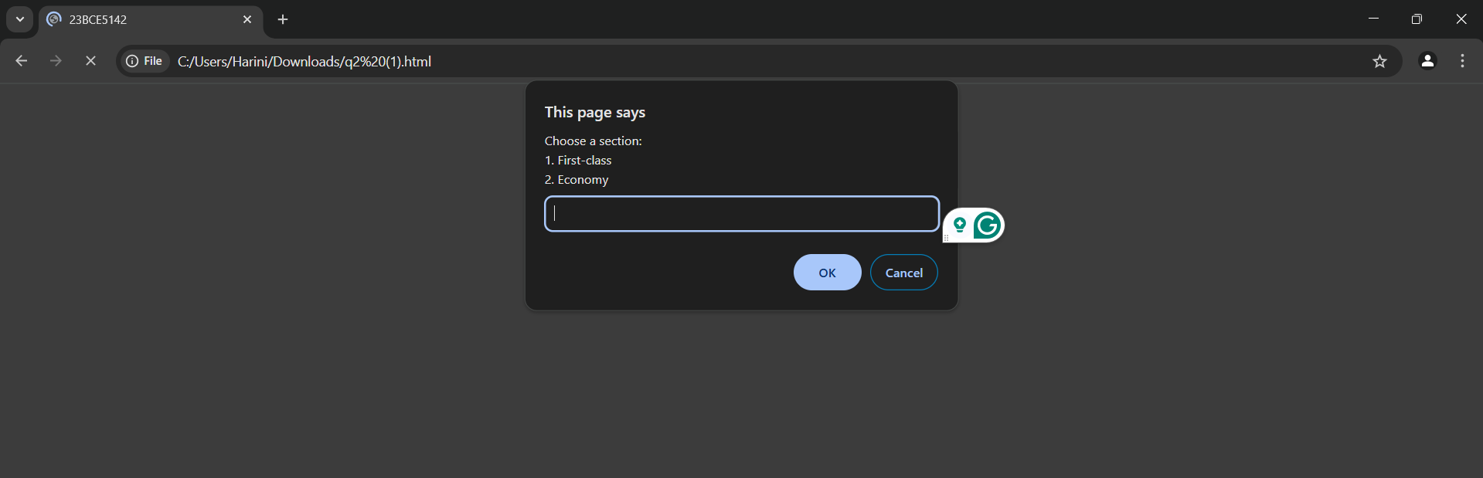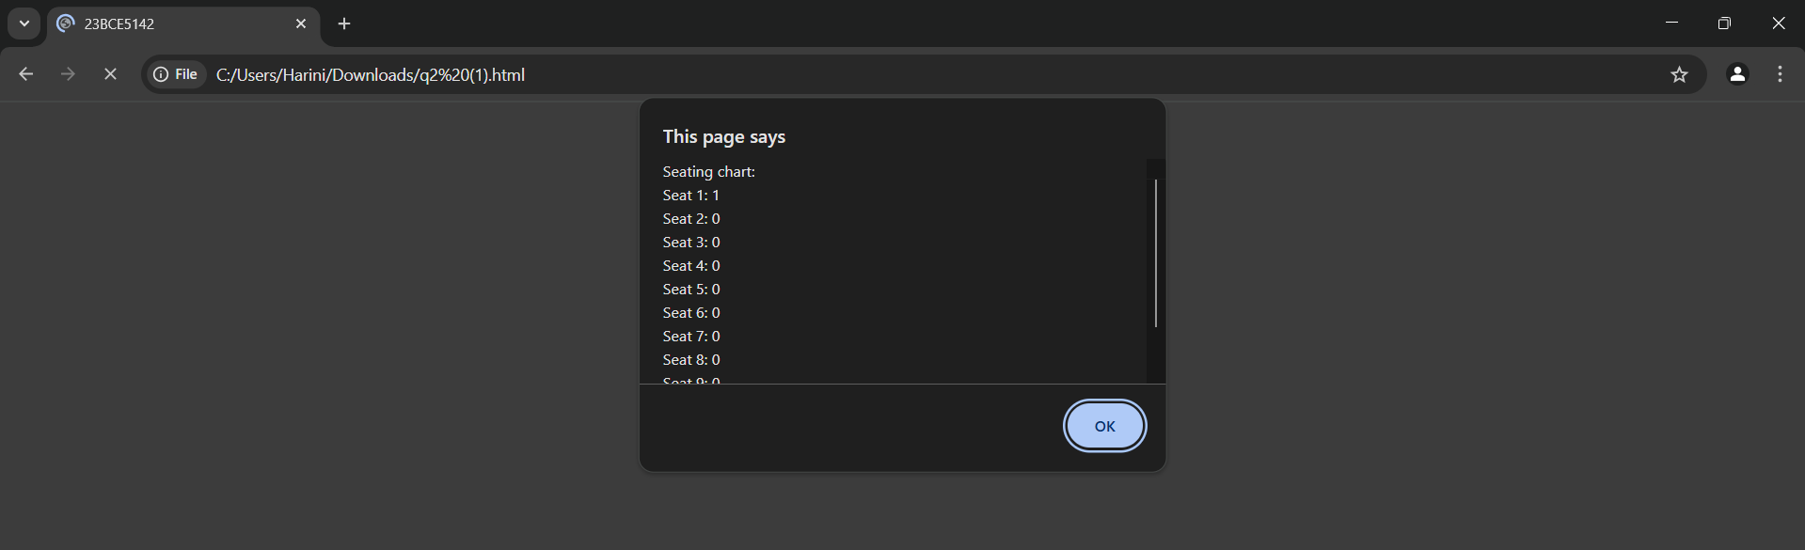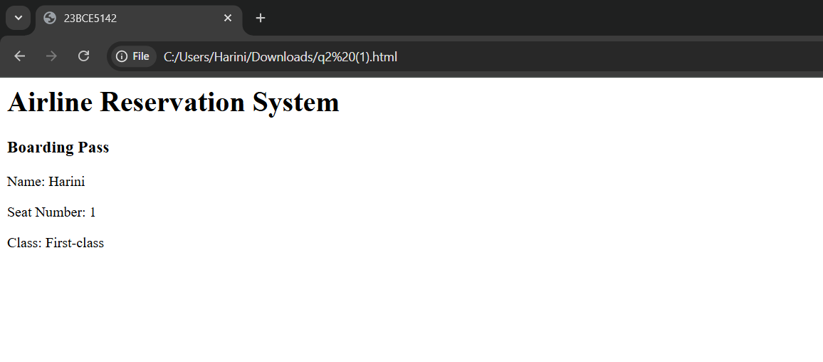<html>

<head>

    <title>23BCE5142</title>

</head>

<body>

<h1>Airline Reservation System</h1>

<div id="boarding-pass"></div>

<script>

    let seats = new Array(10).fill(0);

    function displaySeats() {

        let seatStatus = "Seating chart: \n";

        for (let i = 0; i < seats.length; i++) {

            seatStatus += `Seat ${i + 1}: ${seats[i]} \n`;

        }

        return seatStatus;

    }

    function assignSeat() {

        let sectionChoice = prompt("Choose a section: \n1. First-class \n2. Economy");

        let seatAssigned = false;

        let name = prompt("Enter your name:");

        let seatNumber;

        if (sectionChoice == '1') {

            for (let i = 0; i < 5; i++) {

                if (seats[i] === 0) {

                    seats[i] = 1;

                    seatNumber = i + 1;

                    seatAssigned = true;

                    break;

                }

            }

            if (!seatAssigned) {

                let switchToEconomy = confirm("First-class is full. Would you like to sit in the Economy section?");

                if (switchToEconomy) {

                    for (let i = 5; i < 10; i++) {

                        if (seats[i] === 0) {

                            seats[i] = 1;

                            seatNumber = i + 1;

                            seatAssigned = true;

                            break;

                        }

                    }

                }

            }

        }

        else if (sectionChoice == '2') {

            for (let i = 5; i < 10; i++) {

                if (seats[i] === 0) {

                    seats[i] = 1;

                    seatNumber = i + 1;

                    seatAssigned = true;

                    break;

                }

            }

            if (!seatAssigned) {

                let switchToFirstClass = confirm("Economy is full. Would you like to sit in the First-class section?");

                if (switchToFirstClass) {

                    for (let i = 0; i < 5; i++) {

                        if (seats[i] === 0) {

                            seats[i] = 1;

                            seatNumber = i + 1;

                            seatAssigned = true;

                            break;

                        }

                    }

                }

            }

        }

        if (seatAssigned) {

            let seatClass = (seatNumber <= 5) ? "First-class" : "Economy";

            let boardingPass = `<h3>Boarding Pass</h3>

                                <p>Name: ${name}</p>

                                <p>Seat Number: ${seatNumber}</p>

                                <p>Class: ${seatClass}</p>`;

            document.getElementById("boarding-pass").innerHTML = boardingPass;

        } else {

            alert("Sorry, no seats are available in either section.");

        }

        alert(displaySeats());

    }

    assignSeat();

</script>

</body>

</html>

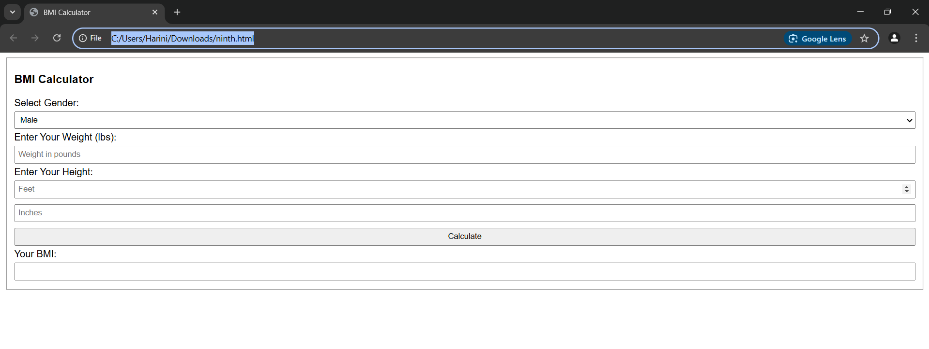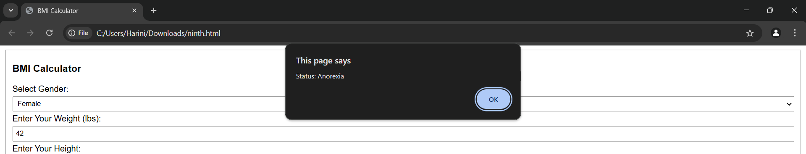<html>

<head>

    <title>BMI Calculator</title>

    <style>

        body {

            font-family: Arial, sans-serif;

        }

        input, select, button {

            width: 100%;

            margin: 5px 0;

            padding: 5px;

        }

    </style>

</head>

<body>

    <fieldset>

    <h3>BMI Calculator</h3>

    <label>Select Gender:

    <select id="gender">

        <option value="male">Male</option>

        <option value="female">Female</option>

    </select>

    <label>Enter Your Weight (lbs):</label>

    <input type="number" id="weight" placeholder="Weight in pounds">

    <label>Enter Your Height:</label>

    <input type="number" id="feet" placeholder="Feet">

    <input type="number" id="inches" placeholder="Inches">

    <button onclick="calculateBMI()">Calculate</button>

    <label>Your BMI:</label>

    <input type="text" id="bmiResult" readonly>

    </fieldset>

<script>

    function calculateBMI() {

        let gender = document.getElementById("gender").value;

        let weight = document.getElementById("weight").value;

        let feet = document.getElementById("feet").value;

        let inches = document.getElementById("inches").value;

        if (!weight || !feet || !inches) {

            alert("Please enter all values!");

            return;

        }

        let heightInInches = (parseInt(feet) \* 12) + parseInt(inches);

        let bmi = (703 \* parseFloat(weight)) / (heightInInches \* heightInInches);

        bmi = bmi.toFixed(2);

        let status = "";

        if(gender=="female"){

        if (bmi < 17.51) {

            status = "Anorexia";

        } else if (bmi >= 17.5 && bmi <= 19.1) {

            status = "Underweight";

        } else if (bmi >= 19.11 && bmi <= 25.8) {

            status = "Ideal range";

        } else if (bmi >= 25.8 && bmi <= 27.3) {

            status = "Ideal range";

        }

        else if (bmi >= 27.3 && bmi <= 32.3) {

            status = "Overweight range";

        }

        else {

            status = "Obese";

        }}

        else{

        if (bmi < 17.51) {

            status = "Anorexia";

        } else if (bmi >= 17.5 && bmi <= 20.7) {

            status = "Underweight";

        } else if (bmi >= 20.7 && bmi <= 26.4) {

            status = "Ideal range";

        } else if (bmi >= 26.4 && bmi <= 27.8) {

            status = "Ideal range";

        }

        else if (bmi >= 27.8 && bmi <= 31.1) {

            status = "Overweight range";

        }

        else {

            status = "Obese";

        }}

        document.getElementById("bmiResult").value = bmi;

        alert("Status: " + status);

    }

</script>

</body>

</html>